How Big is the Problem in Three Largest U.S. Cities?

**FOOD DESERTS BY ZIPCODE**   
DATA SOURCES



Los Angeles



Chicago



New York

* There are three sets of data needed for this analysis
  + Income by Zip Code
  + Zip Codes in target cities
  + Grocery Stores near a Zip Code
* The next pages explain these data sources and their use

Data Sources for Food Deserts by Zip Code

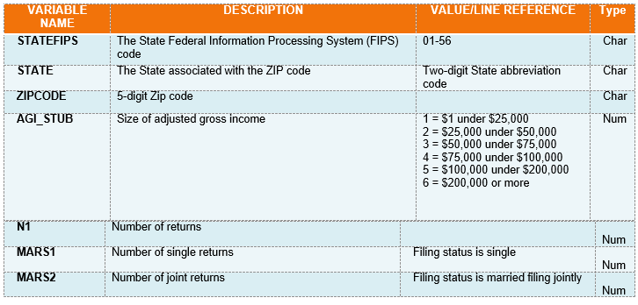

* For income by zip code, this analysis will be using the 2017 income tax file available at [www.irs.gov/statistics/soi-tax-stats-individual-income-tax-statistics-2017-zip-code-data-soi](http://www.irs.gov/statistics/soi-tax-stats-individual-income-tax-statistics-2017-zip-code-data-soi). The IRS data contains information by 6 major income groups for each zip code and indicates the individual line item information on U.S. Income Tax forms 1040, 1040A, 1040EZ. The information will be used to create an average income by zip code for correlation and comparative purposes.
* The Data Dictionary for this file can be downloaded “www.irs.gov/pub/irs-soi/17zpdoc.docx”. Some rows from the Data Dictionary are below:

Data Sources – Income by Zip Code